OFFICE OF INSTITUTIONAL RESEARCH

FLORIDA STATE UNIVERSITY

318 WESTCOTT BUILDING | TALLAHASSEE, FL 32306-1359

Emily Šaras, Student Outcomes Analyst
esaras@fsu.edu | 850-644-7432

April 25, 2018

DATA REQUEST

Post-Graduation Outcomes of Masters of Science in Information Graduates, 2016-17
Master’s Graduating Survey (MGS) Data, 2016-17

SUMMARY

This report documents the outcomes of Masters of Science in Information graduates (CIP = 11.0401) who graduated in 2016-17, as self-reported by students in the 2016-17 Master’s Graduating Survey (MGS).

POST-GRADUATION PLANS

Below are the post-graduation outcomes of this population. The majority (91%, N=60) of Masters of Science in Information graduates had a primary post-graduation plan of securing employment or continuing in their current role.

Fig. 1. Post-Graduation Plans for Masters of Science in Information Graduates, 2016-17
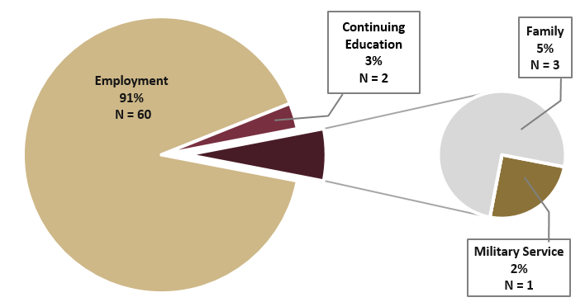
N = 66

ABOUT THIS DATA SAMPLE
The sample population used in this report includes master’s students graduating from FSU in Summer 2016, Fall 2016, and Spring 2017. We surveyed students electronically during the last few weeks of their final FSU semester, at a 67.3% response rate. After accounting for respondent eligibility factors, such as whether the survey respondent successfully completed his or her degree during the specified timeframe, the final sample includes 1,398 respondents. The Masters of Science in Information Degree Program had 87 graduates in Summer 2016 – Spring 2017. Of this population, 66 completed the MGS survey, a response rate of 75.9%.
POST-GRADUATION OUTCOMES

Of the 91% (N=60) of Masters of Science in Information graduates who reported a primary post-graduation plan of securing employment or continuing in their current role, 47% (N = 28) were actively applying to new jobs at the time of graduation when completing this survey. Of these applicants, 14% (N = 4) were offered jobs, and 100% (N = 4) of graduates who were offered jobs had accepted them.

Note: Unlike the FSU Graduating Senior Survey (GSS) for undergraduates, the MGS survey only collects data at time of graduation, before some graduates have begun their job search.

Fig. 2. Employment Outcomes for Masters of Science in Information Graduates, 2016-17
Focus: Students Whose Primary Plan is Employment After Graduation
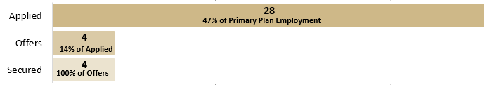
N = 60

Of the 3% (N = 2) of Masters of Science in Information graduates who reported a primary post-graduation plan of continuing education, 100% (N = 2) applied, were offered admission, and enrolled in graduate school.

Fig. 3. Education Outcomes for Masters of Science in Information Graduates, 2016-17
Focus: Students Whose Primary Plan is Continuing Education After Graduation
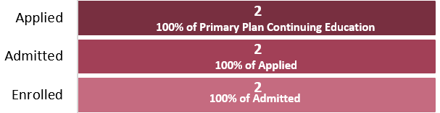
N = 2

POST-GRADUATION EMPLOYERS AND POSITION TITLES

Graduates were asked to self-report their current or future employer.

Of the 91% (N = 60) of Masters of Science in Information graduates who reported a primary post-graduation plan of securing employment or continuing in their current role, 50% (N = 30) self-reported a position and title. Students who were already employed and did not intend to pursue a job search had the ability to report their current employer in this section.

Below is a listing of the 30 positions reported by Masters of Science in Information graduates, grouped alphabetically by employer.

Table 1. Employers and Position Titles for Masters of Science in Information Graduates, 2016-17
Employer | Position Title | Number of Graduates
Alachua County Library District | Librarian, Teen Services | 1
 | Library Specialist, Children's Programmer | 1
College / University, Unnamed | Librarian, Teen Services | 1
 | Professor | 1
 | Africana Librarian / Adjunct Assistant Professor of History | 1
 | Assistant Librarian | 1
 | Library Assistant III | 1
 | Library Associate | 2
 | Library Specialist | 1
 | Scholarly Communication Adjunct Librarian | 1
 | Senior Library Assistant | 1
 | Visual & Performing Arts Librarian | 1
Community Christian School | Youth Services Librarian | 1
DRS Technologies | Technical Writer | 1
Fairfax County Public Schools | Librarian, Teen Services | 1
Fayetteville Public Library | Manager, Circulation Services | 1
Florida Department of Health | Medical/Health Care Program Analyst | 1
Florida International University Libraries | Metadata Specialist | 1
Miami Dade public library system | Librarian, Teen Services | 1
New Canaan Library | Librarian | 1
New Castle County | Principal Library Assistant | 1
New Castle County Library System | Library Specialist, Cataloging | 1
Random Everglades School | Librarian, Teen Services | 1
Roanoke City Public Libraries | Librarian, Teen Services | 1
Roanoke Public Libraries | Library Assistant | 1
SC Transportation | Event Coordinator | 1
South Charleston Public Library | Youth Services Librarian | 1
Suwannee County School Board | Media Specialist | 1
Unnamed School | Unnamed Position | 1
N = 30

